**Design of Microstrip Patch Antenna for 5g application**

**Submitted**

**By**

**P Hari Priya**

**K Poojitha**

**V Deekshitha**

**BU21EECE0100389**

**BU21EECE0100088**

**BU21EECE0100148**

**Akhilendra Pratap Singh**

**Akhilendra Pratap Singh, Designation**

**(Duration: Date/Month/Year to Date/Month/Year)**



**Department of Electrical,Electronics and Communication Engineering**

**GITAM School of Technology**

**GITAM**

**(DEEMED TO BE UNIVERSITY)**

**(Estd. u/s 3 of the UGC act 1956)**

**NH 207, Nagadenehalli, Doddaballapur taluk, Bengaluru-561203 Karnataka, INDIA.**

**DECLARATION**

**I/We declare that the project work contained in this report is original and it has been done by me under the guidance of my project guide.**

**Name: P Hari Priya**

**K Poojitha**

**V Deekshitha**

**Date: Signature of the Student**

**Department of Electrical,Electronics and Communication Engineering**

**GITAM School of Technology, Bengaluru-561203**



**CERTIFICATE**

**This is to certify that( P Hari Priya,K Poojitha,V Deekshitha) bearing (BU21EECE0100389,BU21EECE0100088,BU21EECE0100148) has satisfactorily completed Mini Project Entitled in partial fulfillment of the requirements as prescribed by University for VIIIth semester, Bachelor of Technology in “Electrical, Electronics and Communication Engineering” and submitted this report during the academic year 2024-2025.**

**[Signature of the Guide] [Signature of HOD]**

**Table of contents**

Chapter 1: Introduction 1 1.1 Overview of the problem statement 1 1.2 Objectives and goals 1 Chapter 2 : Literature Review 2

Chapter 3 : Strategic Analysis and Problem Definition 3

3.1 SWOT Analysis 3

3.2 Project Plan - GANTT Chart 3

3.3 Refinement of problem statement 3

Chapter 4 : Methodology 4

4.1 Description of the approach 4

4.2 Tools and techniques utilized 4

4.3 Design considerations 4

**Chapter 5 : Implementation 5**

5.1 Description of how the project was executed 5

5.2 Challenges faced and solutions implemented 5

**Chapter 6:Results 6**

6.1 outcomes 6

6.2 Interpretation of results 6

6.3 Comparison with existing literature or technologies 6

**Chapter 7: Conclusion 7**

**Chapter 8 : Future Work 8**

Here write Suggestions for further research or development Potential improvements or extensions 8

**References 9**

**Chapter 1: Introduction**

Microstrip patch antennas are increasingly pivotal in the development of 5G technology due to their advantageous characteristics such as low profile, lightweight, and ease of integration into various devices. These antennas are particularly suited for high-frequency applications, making them ideal for the demands of 5G networks.

## **Overview of Microstrip Patch Antennas**

Microstrip patch antennas consist of a thin rectangular or circular patch mounted on a dielectric substrate with a ground plane. Their design allows for compactness and ease of fabrication, often utilizing printed-circuit technology. This makes them suitable for modern communication devices like smartphones, laptops, and IoT devices.

## **Key Features:**

* **Low Profile:** They can be easily integrated into mobile devices.
* **Lightweight:** Ideal for portable applications.
* **Cost-Effective:** Manufacturing is simplified through printed-circuit techniques.

**1.1 Overview of the problem statement**

## **1. Bandwidth Limitations**

## **2. Gain and Efficiency**

## **3. Complex Design Requirements**

## **4. Material Constraints**

## **5. Integration with Modern Devices**

* 1. **Objective**

The purpose of this project is to develop a Microstrip patch antenna that operates at a frequency of 5 GHz this patch antenna can obtain higher gain values at higher frequencies 10GHZ, one of the frequency bands for 5G, and may be utilized in small devices like mobile phones, radios, and wireless computers.The goal of this project is to design a high-performance microstrip antenna specifically optimized for 5G applications. The project will involve simulation ensure the antenna meets the requirements of 5G networks.

**Goals**

Main Goals

• Gain

• Radiation Pattern

**Chapter 2 : Literature Review**

**Abstract:**

The rapid development of 5G technology necessitates the design of efficient, compact, and high-performance antennas to meet the stringent requirements of modern wireless communication systems. This project will focus on the design and analysis a microstrip patch antenna optimized for 5G applications. The antenna will feature a compact size, low profile, and planar structure, making it suitable for integration into various 5G devices, including smartphones and IoT devices. The project will involve the detailed design and optimization of the antenna, focusing on key parameters such as substrate selection, patch dimensions, and feed techniques to achieve the desired performance. The antenna will be designed to operate in frequency bands which are widely recognized for 5G communications using advanced simulation software. Through simulation and practical implementation, the project aims to achieve a high gain, wide bandwidth, and excellent impedance matching, ensuring efficient signal transmission and reception in 5G environments. Additionally, the project will explore the antenna's radiation pattern, polarization, and performance in various environmental conditions, ensuring its robustness and reliability for real-world 5G applications. The compact and efficient design of the microstrip patch antenna are expected to meet the demands of 5G networks, offering a practical solution for integrating high-performance antennas into modern communication devices. The outcomes of this project are expected to contribute significantly to the development of 5G technology, enabling faster data rates, lower latency, and enhanced connectivity in next-generation wireless networks.

|  |  |  |  |  |
| --- | --- | --- | --- | --- |
| **S.NO** | **TITLE** | **AUTHOR** | **YEAR OF**  **PUBLISHING** | **DRWABACKS** |
| 1. | Design and implementation of microstrip patch antenna for 5g application | John Colaco, Rajesh Lohani | 2020 | **.** 5g application  **.** Bandwidth limitation  **.** Radiation pattern  **.** Gain and Efficiency |
| 2. | Design and analysis of a slotted microstrip patch antenna for 5g application network | Abdalnaser F Kaeib,Nafaa M Shebani | 2019 | **.** The book covers a board range of topics, which might be overwhelming for beginners  **.** Some advanced topics may lack detailed explanations and might require supplementary reading |
| 3. | Design and analysis of a slotted microstrip patch antenna for 5g application network | T Kiran, N Mounisha,Ch Mythily,D Akhil | 2018 | **. Limted bandwidth**:Limited frequency range impacts 5g performance  **.** **Low radition efficiency**:Signal losses reduces overall coverage effectiveness  **.** **Insufficient testing**:Lacks comprehensive empirical validation |

**Chapter 3 : Strategic Analysis and Problem Definition**

**3.1 SWOT Analysis**

**Strengths:** Ease of Fabrication , Low Profile , Compact Size

**Weaknesses:** Bandwidth Limitations , Gain Limitations , Efficiency Issues

**Opportunities:** Advanced Materials , Integration with 5G Technologies

**Threats:** Manufacturing Challenges , Competitive Technologies

**3.2 Project Plan - GANTT Chart**

**Gant Chart -** Milestones and Activities

**Resources :**hfss

Our project plan is to design microstrip patch antenna for 5g applications and to find radiation pattern, gain of antenna using hfss software with frequency of 5GHZ

**3.3 Refinement of problem statement**

The rapid advancement of fifth-generation (5G) wireless communication technology necessitates the development of efficient, compact, and high-performance antennas. Microstrip patch antennas are increasingly favored for 5G applications due to their low profile, lightweight nature, and ease of integration into various devices.

**Chapter 4 : Methodology**

The methodology for designing microstrip patch antennas for 5G applications involves several systematic steps, focusing on optimizing performance characteristics such as bandwidth, gain, and efficiency. Here’s an overview of the typical methodology used in recent studies.

## **1.Design Specifications**

## **.Frequency Selection:** Identify the operating frequency range suitable for 5G applications, typically around sub-6 GHz and mmWave frequencies (e.g., 24 GHz to 39 GHz)

**.** **Antenna Type:** Choose the type of microstrip patch antenna (rectangular, circular, or array configurations) based on application requirements. Arrays are often preferred for MIMO applications to enhance capacity and coverage

**2. Material Selection**

**.Dielectric Substrate:** Select a dielectric material with appropriate properties (dielectric constant, loss tangent) that supports the desired frequency range. Common materials include Rogers Ultralam and FR-4

**.Patch Material:** Typically, copper or other conductive materials are used for the patch due to their excellent conductivity.

**4.1 Description of the approach**

This comprehensive approach ensures that microstrip patch antennas are effectively designed for 5G applications, addressing challenges related to bandwidth, gain, and integration into compact devices. The iterative process of design, simulation, testing, and optimization is crucial for meeting the stringent requirements of modern wireless communication technologies.

**4.2 Tools and techniques utilized**

The approach to designing microstrip patch antennas for 5G applications leverages advanced simulation tools like Ansys HFSS and CST Studio Suite, employs various feeding techniques for optimal performance, selects appropriate materials, and rigorously analyzes performance metrics. This comprehensive methodology ensures that the antennas meet the demanding requirements of modern wireless communication systems.

**4.3 Design considerations**

The design considerations for microstrip patch antennas in 5G applications encompass a range of factors from frequency selection to material choice and feeding techniques. By addressing these considerations systematically, designers can create antennas that meet the stringent requirements of modern wireless communication systems while ensuring efficiency and compactness.

**Chapter 5 : Implementation**

5.1 Description of how the project was executed

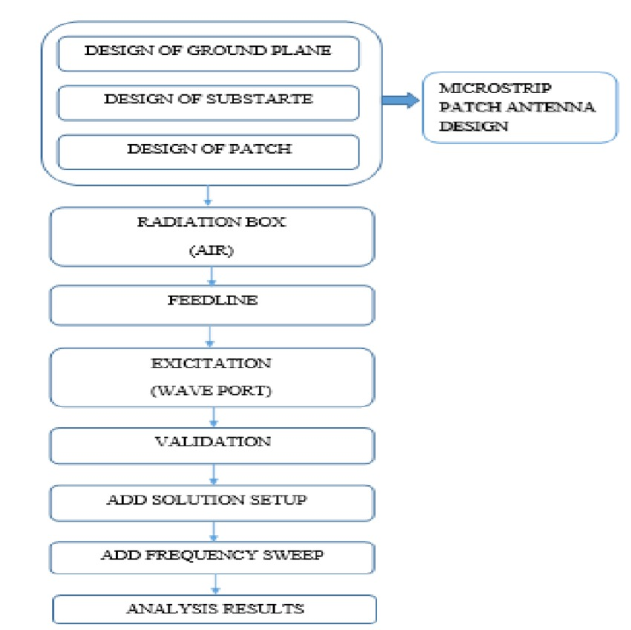

**5.2 Challenges faced and solutions implemented**

The challenges faced in designing microstrip patch antennas for 5G applications are significant but manageable through innovative solutions such as optimized geometries, advanced materials, array configurations, and sophisticated simulation techniques. These strategies not only enhance performance metrics but also ensure that antennas can be effectively integrated into modern wireless communication devices.

**Chapter 6:Results**

6.1 outcomes

6.2 Interpretation of results

6.3 Comparison with existing literature or technologies

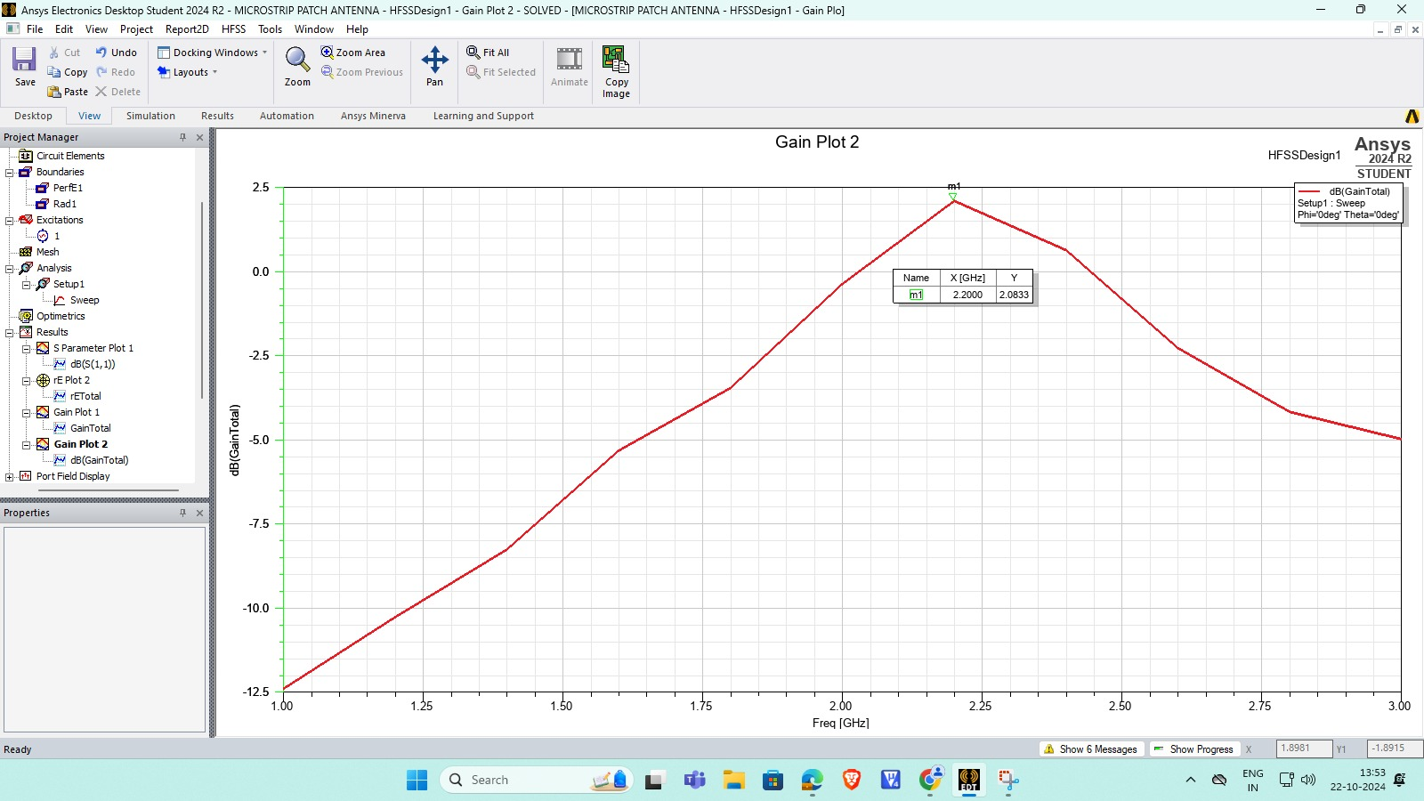

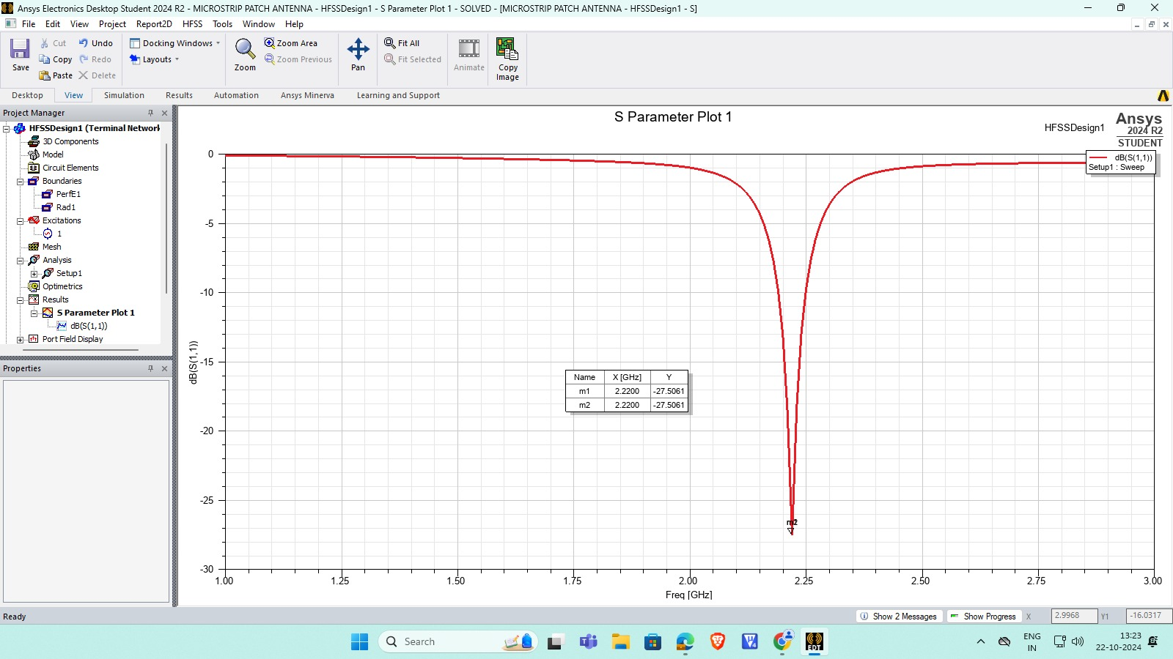

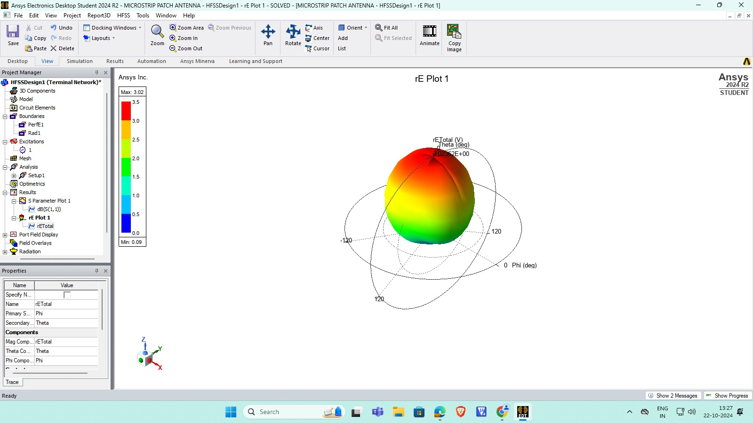

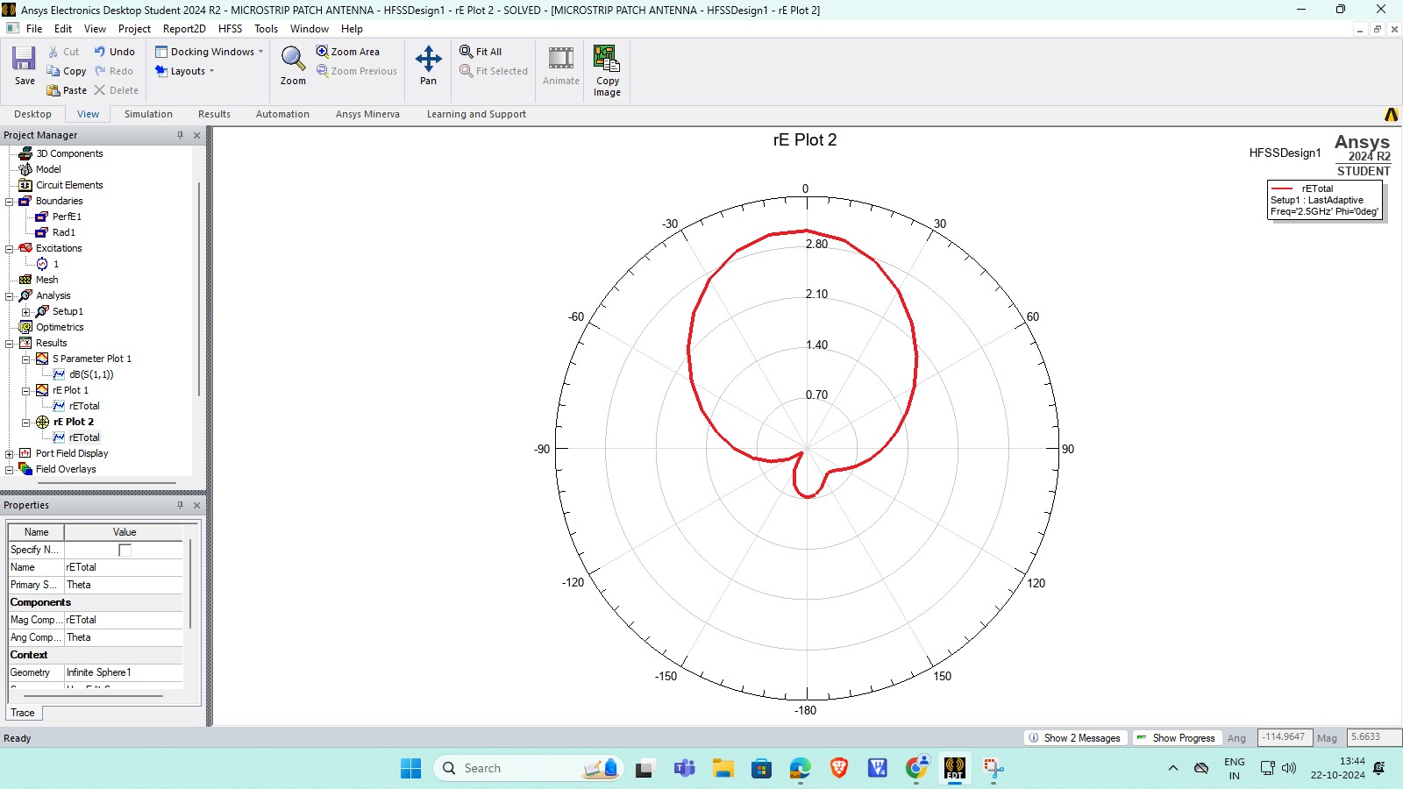

**Chapter 7: Conclusion**

Microstrip patch antennas are crucial for 5G applications, operating primarily in the millimeter-wave spectrum (24 GHz to 30 GHz). Their compact design enables integration into small devices while providing wide bandwidth and high efficiency (≥80%). They maintain reliable performance across various temperatures and support both linear and circular polarization. Multi-element array configurations enhance directivity and gain, making them ideal for advanced beamforming techniques. Ongoing innovation in these designs will ensure the successful deployment of 5G technologies.

**Chapter 8 : Future Work**

Future work on microstrip patch antennas for 5G will focus on optimizing designs for improved performance, integrating advanced simulation techniques, developing reconfigurable systems, and conducting real-world testing to ensure reliability, adaptability, and cost-effectiveness in various applications.

**References:**

1. [**https://scholar.google.co.in/scholar?start=10&q=ieee+papers+for+design+of+microstrip+patch+antenna+for+5g+application&hl=en&as_sdt=0,5&as_vis=1**](https://scholar.google.co.in/scholar?start=10&q=ieee+papers+for+design+of+microstrip+patch+antenna+for+5g+application&hl=en&as_sdt=0,5&as_vis=1)
2. [**https://scholar.google.co.in/scholar?start=10&q=ieee+papers+for+design+of+microstrip+patch+antenna+for+5g+application&hl=en&as_sdt=0,5&as_vis=1**](https://scholar.google.co.in/scholar?start=10&q=ieee+papers+for+design+of+microstrip+patch+antenna+for+5g+application&hl=en&as_sdt=0,5&as_vis=1)
3. [**https://scholar.google.co.in/scholar?q=ieee+papers+for+design+of+microstrip+patch+antenna+for+5g+application&hl=en&as_sdt=0&as_vis=1&oi=scholart**](https://scholar.google.co.in/scholar?q=ieee+papers+for+design+of+microstrip+patch+antenna+for+5g+application&hl=en&as_sdt=0&as_vis=1&oi=scholart)